Resuming the lab book… big gap between 07/31/2012 and now due to a building phase:

* New optical table
* Diode lasers
* Frequency comb with it’s locks (rep rate, CEP lock,…)
* Setup of BEC1 dye laser and tweaking
* Setup of high-finesse cavity and corresponding vacuum chamber
* Exploration of several locking schemes
* …

November 7, 2012

**Start of Autler-Townes (Dark-Resonance) Spectroscopy**

**Laser setup:**

* The Ti:Sapph is locked to an Invar Cavity (Coherent) using a side-of-fringe lock. The cavity is fairly stable. In order to change the cavity length by one free spectral range a temperature change by 2 Kelvin is required. Since the lab temperature is not that stable, we actually need to make sure that the cavity stays in the right temperature range… the piezo only travels about 1.5 free spectral ranges. For now we perform heating of the cavity with a heat foil, but no active stabilization, since the Thorlabs temperature controller does not work with the high resistance (~300 Ohms) foil (a TEC has only <1 Ohms). The Invar Cavity is locked to the Potassium atomic reference at 767 nm, i.e. actively the cavity length is thereby actively stabilized. This lock is also a side-of-fringe lock. A side-of-fringe lock bears the risk of frequency fluctuations induced by amplitude fluctuation. However, we estimate that these fluctuations should only lead to fluctuations on the level of a MHz, which is lower than the accuracy we aim for. For the Ti:Sapph locking light is outcoupled directly after the output and send to the “new” optical table with a fiber.
* The feedback signal obtained from the invar cavity is given directly to the Ti:Sapph cavity piezo (input: “resonator”). By this we entirely bypass the external cavity of the Ti:Sapph. Initially, we wanted to give the feedback to piezo of the external reference cavity of the laser, just as is typically done with the Coherent 899. However, we eventually did not do this, as the laser showed enormous 60Hz frequency noise when the “reference cavity” input was connected to any external device; without a connection to the outside world, the laser would operate ok. It seems like a ground loop issue, maybe in the controller box. It might be that the reference cavity locking electronics has been implemented quick and dirty on top of an existing electronics board. When the feedback is directly given to the resonator piezo, we are left with an extremely quiet laser.
* Ti:Sapph stability monitored over the course of about 5 mins; we are quite happy:

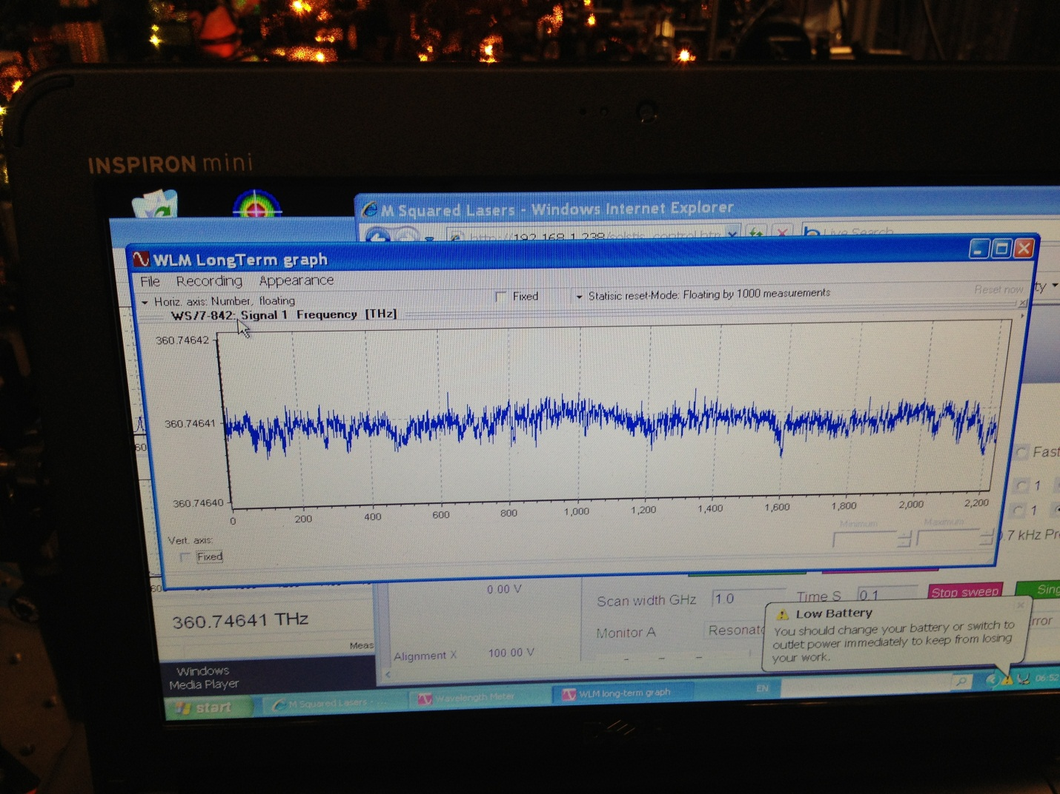

* The main Ti:Sapph beam is sent through a double pass AOM (80MHz) and coupled to a fiber; in front of the fiber coupling a pick-up sends some light to a wavemeter. The power of this beam is simply tuned by the RF power in the double pass.
* The Dye laser is “only” locked to its reference cavity. On the time scale of a single run this is typically stable to the 1MHz level. This is completely sufficient, because we vary and monitor the frequency of the dye laser in each shot.
* On the experimental table we use about 10mW of Ti:Sapph light (probe) and about 200mW of Dye laser light (drive). If the coupling on the two transitions is comparable, this should correspond to Omega1 << Omega2, as it needs to be in order to observe Autler-Townes.
* We start at our “famous” 832nm line, the first deeply bound line that we found on July 10, 2012. On July we give a wavelength of **832.4207nm**. (On July 11, 2012 we also found a feature at **832.4006nm**. This could also be the hyperfine mixed state! Let’s not forget about this one!) This corresponds to a Ti:Sapph frequency of 360.14512 THz (832.42123nm), according to a later measurement with lower laser intensity.

November 8, 2012

**Autler-Townes search around the 832nm resonance:**

(A) We figure out the transition range, within which we should search.

Given the first photon to be at **832.42123nm** (corresponding to **12013.1 1/cm** or **360145.137 GHz** ) we can figure out the second photon by knowledge of the v=0 dissociation energy of the ground state potential. According to Tiemann, this is

**5211.75 1/cm** for **Na39K.**

In Martin’s Mathematica sheet “RKRpotentials Master.nb” the mass-scaled ground state potential is figured out. The v=0 energy shifts down by -0.2875 1/cm. This gives us a dissociation energy of

**5212.04 1/cm** for **Na40K.**

This yields the a most likely value of the second photon of:

**f2 = 516398.465 GHz**

* **k2 = 17225.2 1/cm**
* **lambda2 = 580.544828 nm**

We note that Tiemann gives an error of +-0.1 1/cm on the dissociation energy resulting from the imprecise knowledge of the long-range potential. In order to have a confidence of 95% we should at least search within +-0.2 1/cm around the proposed f2. This means:

**f2 = 516392.100 GHz … 516404.100 GHz** generously corresponding to **+- 7GHz**

(B) Here is what we see:

(C) What else can we do?

* Try out the resonance that we found at **813.701nm**. This line lies exactly on the prediction for the B1Pi state and is at least 1nm away from the prediction of any other molecular potential. Worth trying!
* We could go to one of the several lines found in the vicinity of **820.15nm**. According to prediction here B1Pi and TripletSigmaPlus are close and might strongly couple.
* Alternatively we can perform a precision measurement of the position of an (hopefully) unperturbed TripletSigmaPlus level (possibly 839.091nm ?). Together with the knowledge of the measured excitation energies in heatpipe experiments (Amanda Ross, Tiemann) this gives us experimental information on the ground state dissociation energy.